LAB – 2

1. **Describe Load Balancing and its significance in Cloud Environment**

In order to ensure effective resource usage, increase throughput, minimize reaction time, and prevent overloading any single server, load balancing—which includes dispersing incoming network traffic over numerous servers—is a crucial component of current cloud setups. As load balancing helps to prevent single points of failure and allows for seamless resource scaling based on demand, it is essential for maintaining high availability and scalability of applications and services in a cloud environment.

By diverting traffic away from unreliable or malfunctioning servers, load balancing also significantly improves fault tolerance and reliability. This enhances the overall performance and robustness of cloud-based applications in addition to helping to guarantee continuous service availability.

In a cloud setting, load balancing is essential because it facilitates the effective use of resources, boosts fault tolerance and reliability, guarantees high availability, and optimizes application performance.

1. **List the Load Balancing Service available in AWS, Azure and GCP.**

| **Cloud Provider** | **Load Balancing Service** |
| --- | --- |
| AWS | Elastic Load Balancing (ELB) |
| Azure | Azure Load Balancer |
| GCP | Google Cloud Load Balancing |

**3. Create an AWS EC2 / GCP VM Instances (Instance Name: Regno_EC2_VM1, Regno_EC2_VM2) and install a webserver of your choice in each of the instances to host web site of your organization globally.**

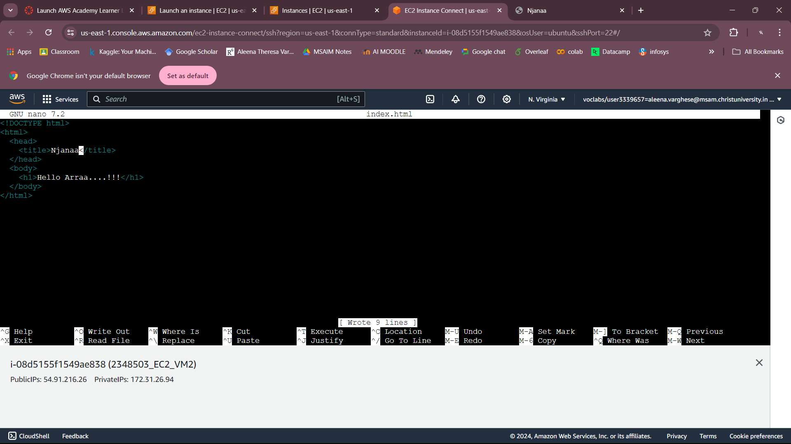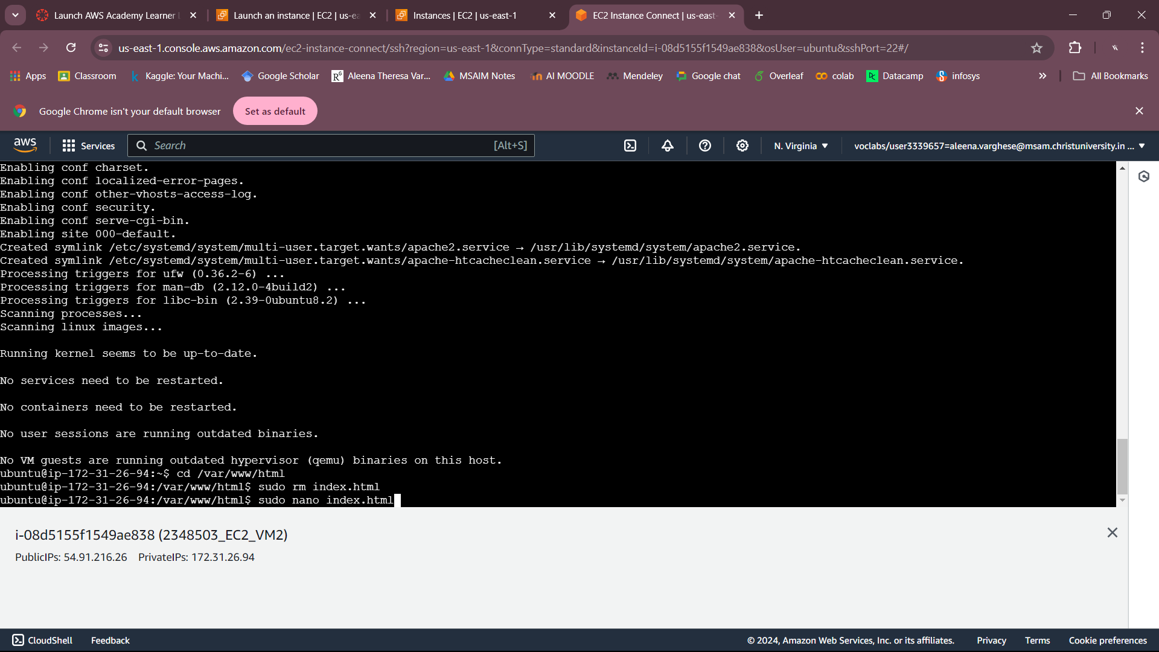

**4. Create a Application Load Balancer to ensure the fare allocation of tasks among the web servers deployed on the Virtual machine instances.**

